**Curried Sweet Potato-Apple Soup**

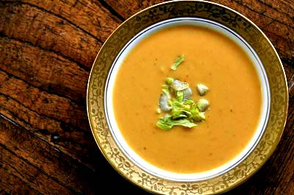

**Ingredients:**

3 medium sweet potatoes

3 tbsp unsalted butter

1 small onion, chopped

2 cloves garlic, smashed

1 2-inch piece of ginger, peeled and grated

¼ tsp. grated nutmeg

1 ½ tsp Madras curry powder

Salt & freshly ground pepper

2 c. low sodium chicken broth

1 ¼ c. chunky applesauce

1 tbsp extra virgin olive oil

1 tbsp apple cider vinegar

1-2 tbsp chopped fresh cilantro

**Preparation:**

1.    Preheat the oven to 425˚. Peel and dice 2 ½ sweet potatoes. Melt 2 tbsp butter in a large pot over medium heat. Add the onion and garlic and cook until soft, about 5 min. Stir in the ginger, nutmeg, 1 ¼ tsp curry power, salt and pepper to taste and cook until toasted, about 1 more minute.

2.    Add the diced sweet potatoes, chicken broth and 2 c. water to the pot. Cover and bring to a boil over medium-high heat. Reduce the heat to medium low and stir in the applesauce. Simmer, covered, until the sweet potatoes are soft, about 20 minutes. Puree the soup with a blender until smooth. Season with salt and pepper; keep warm.

3.    Meanwhile, peel and thinly slice the remaining ½ sweet potato and toss with the olive oil, and salt and pepper to taste. Spread in a single layer on a baking sheet and bake until crisp, 7-10 minutes.

4.    Heat the remaining ¼ tsp curry powder and cook, stirring until browned; remove from the heat and add the vinegar.

5.    Top with the curry butter, cilantro and sweet potato chips.